**AWS NOTES**

Cloud Computing – On demand delivery of IT resources over the internet with pay as you go pricing.

Deployment Types – Cloud Based Deployment ,On-Premises Deployment and Hybrid deployment

Benefits - Trade fixed expense for variable expense, Benefit from massive economies of scale, Stop guessing capacity, Increase speed and agility, Stop spending money to run and maintain data centers, Go global in minutes.

Shared Responsibility Model

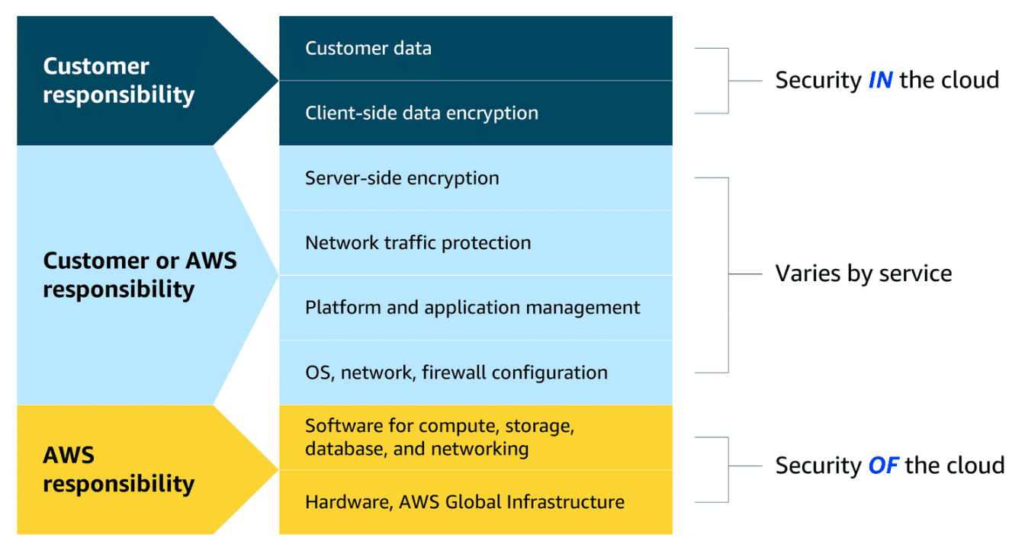

Amazon EC2 – Elastic Computer Cloud

Advantages

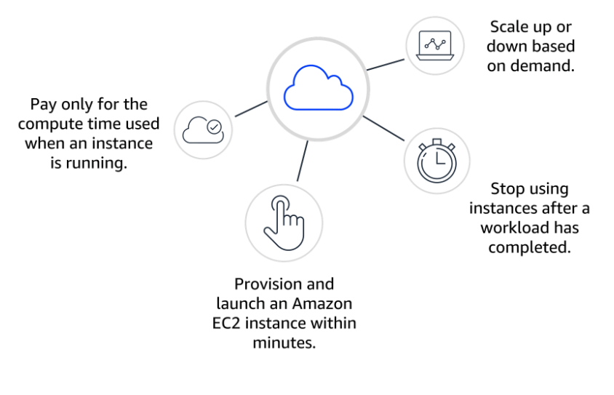

EC2 Instance Type

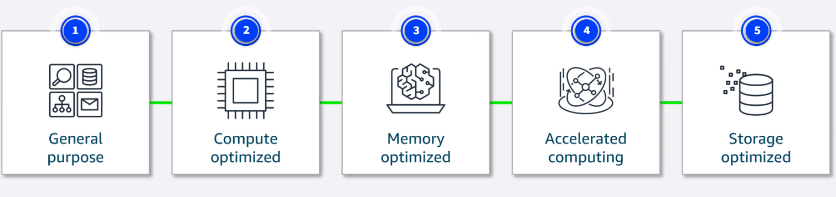

Ways to interact with AWS services

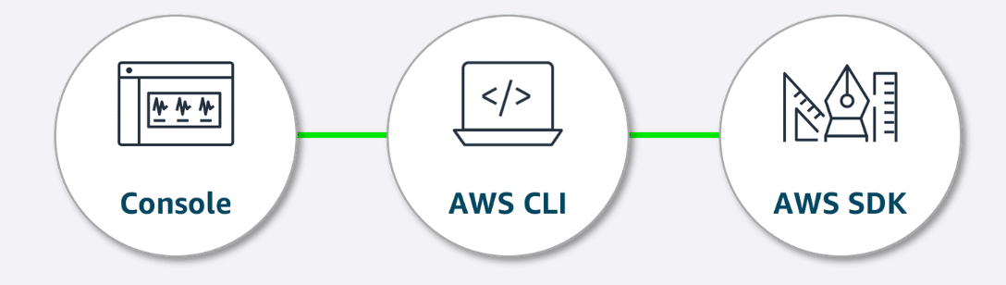

Amazon Machine Images (AMI) - pre-built virtual machine images that have the basic components such as the operating system, storage setup, architecture type, permissions for launching, and any extra software that is already installed.

Ways to use AMIs

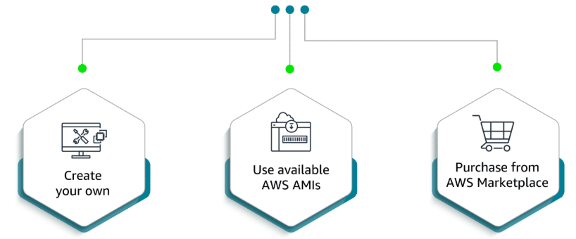

Types of EC2 instances

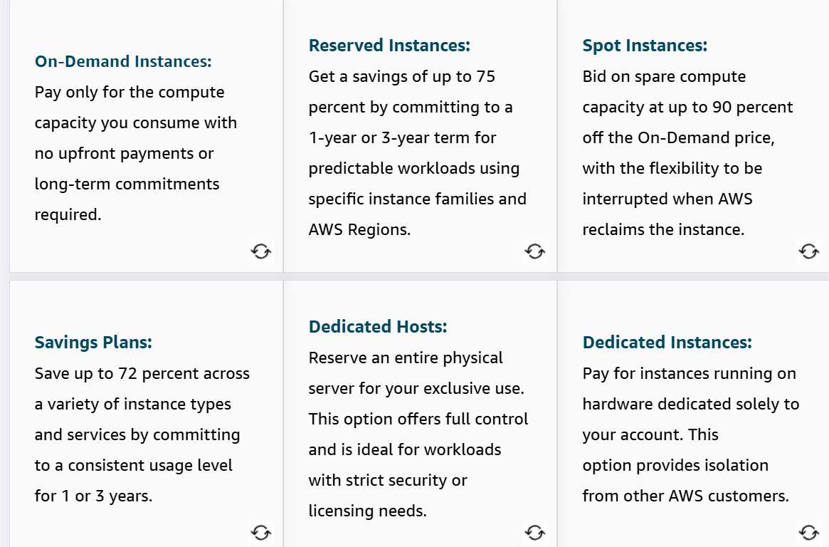

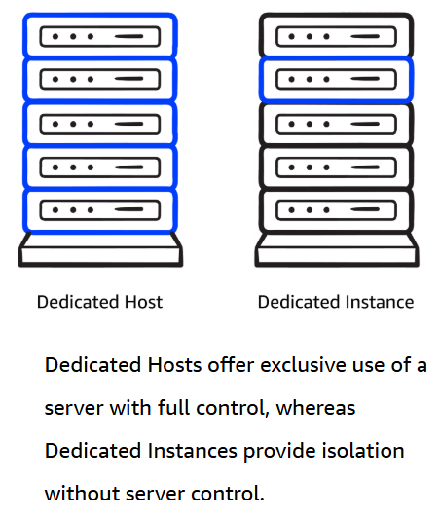

Scalability is about a system’s potential to grow over time, whereas elasticity is about the dynamic, on-demand adjustment of resources.

Amazon EC2 Auto Scaling -  Scaling automatically adjusts the number of EC2 instances based on changes in application demand, providing better availability.

It offers two approaches. *Dynamic scaling* adjusts in real time to fluctuations in demand. *Predictive scaling*preemptively schedules the right number of instances based on anticipated demand.



Elastic Load Balancing (ELB) - automatically distributes incoming application traffic across multiple resources, such as EC2 instances, to optimize performance and reliability.

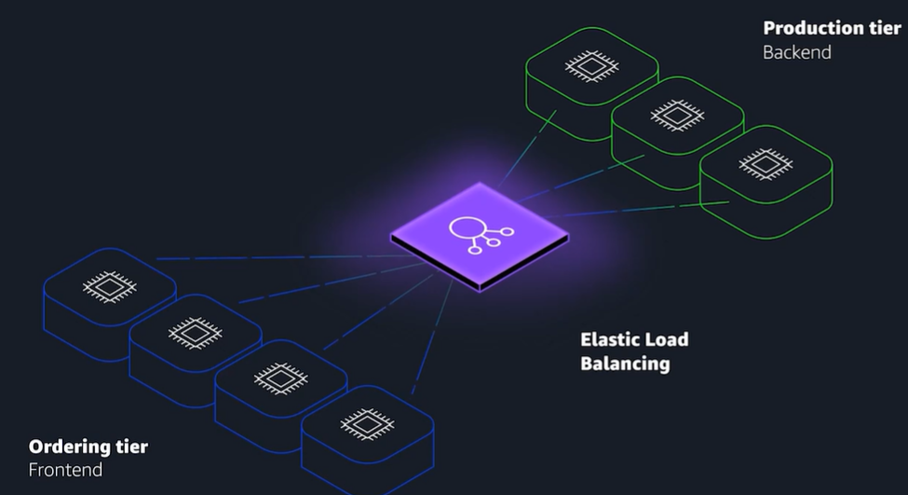

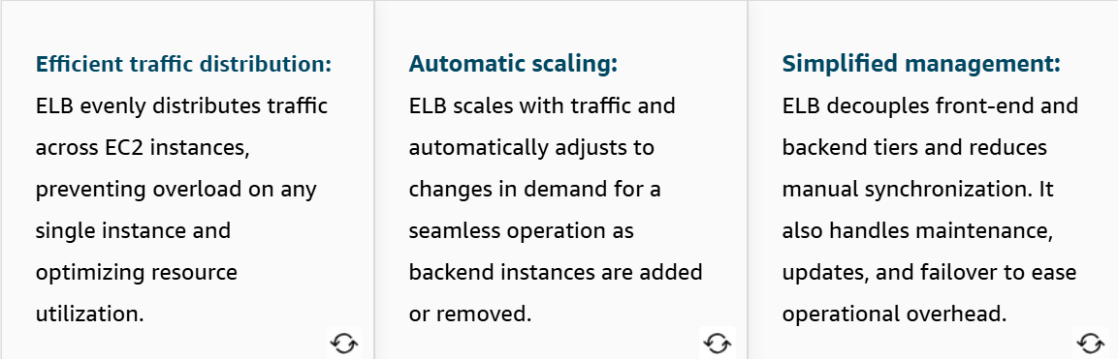

Routing Methods –

